**IEC-Bus Breakout Board Rev. 0**

**Module Description**

This board serves as a breakout board for the Commodore IEC-bus. It already contains the required driver IC (74LS06) and a 74LS04 as a receiver (which resembles the original Commodore hardware).

The purpose is connecting the IEC-bus to microcontroller (modules) like an Arduino, as Raspberry Pi or a Raspberry Pi pico microcontroller. It would be possible to wire up a Pi1541 drive emulator.

For the Raspberry Pis, a lever shifter5 circuit is required, which is also implemented in this board. It can either be placed on-board as SMD components (8x 10k 0805 resistors and 4x BSS138 SOT-23 transistors). Alternatively, a pretty common level shifter module can be soldered to the board or put on soldered in socket strips.

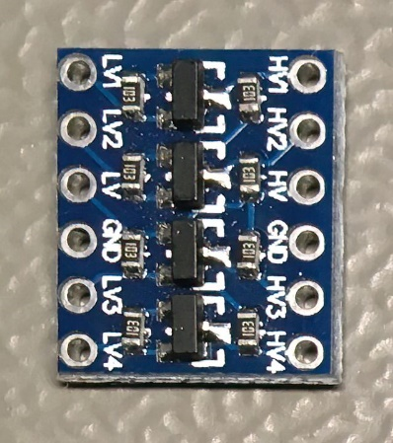

Figure 1: Level shifter module board

The dimensions of the level shifter module are approximately 12.7mm x 15.3mm. It is almost a standard module, which is available from AliExpress, Ebay, Amazon etc.

# Pinouts

## J1 - IEC-Bus

Lumberg 010599 06, 6p DIN receptacles

|  |  |
| --- | --- |
| Pin | Signal |
| 1 | /SRQ (not used in this design) |
| 2 | GND |
| 3 | ATN |
| 4 | CLK |
| 5 | DATA |
| 6 | /RESET |

## J4 - +5VDC Power

5,5mm/2,5mm barrel connector

|  |  |
| --- | --- |
| Pin | Signal |
| Inner lead | +5VDC |
| Outer lead | GND |

## J2 - 3.3V Level Pin Header

1x9 pin header (2.54mm)

|  |  |  |
| --- | --- | --- |
| Pin | Signal | Direction |
| 1 | GND | - |
| 2 | ATN_IN | µC input |
| 3 | CLK_IN | µC input |
| 4 |  | µC output |
| 5 | DATA_IN | µC input |
| 6 |  | µC output |
| 7 |  | µC input |
| 8 | +3.3V | - |
| 9 | +5V | - |

## J3 – 5V (TTL) Level Pin Header

1x9 pin header (2.54mm)

|  |  |  |
| --- | --- | --- |
| Pin | Signal | Direction |
| 1 | GND | - |
| 2 | ATN_IN (5V) | µC input |
| 3 | CLK_IN (5V) | µC input |
| 4 |  | µC output |
| 5 | DATA_IN (5V) | µC input |
| 6 |  | µC output |
| 7 | (5V) | µC input |
| 8 | Not connected | - |
| 9 | +5V | - |

# Dimensions

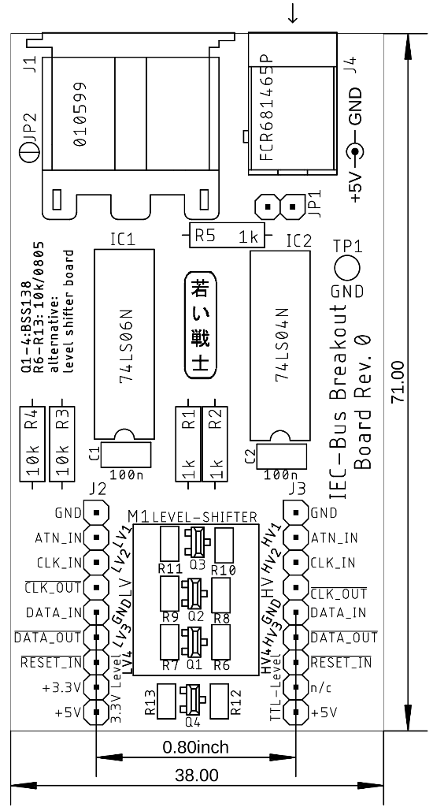

Figure 2: Dimensions of the IEC-bus breakout board

The distance of the pin headers J2 and J3 is 800mil. The pin headers can be place on the component side or the solder side of the board to fit it on a bread board. The width might be too wide to allow access to the receptacle rows. Standard DuPont wires can also serve to connect the board to the micro controller or a Raspberry Pi.

# Revision History

## Rev. 0

* **Untested** prototype